# ABSTRACT

This project concern about doya cloth shopping system, doya cloth shop is found in Bale Robe town. Today the overall activities of the doya cloth shopping system are under taken manually. There repetitive and bulky activities like registering users, reservation, updating records periodically, generating reports and Difficult to integrate data from different individual records, unable to interest different user request. Based on the above problem this project is to automate the existing manual system and producing an automated or electronic (online) product distribution and commercial system throughout the city for the given organization. This project can generate report in easy way. The administrator updates periodical information. The customer order Item online. The system allow to the customers, to search Item in a fast mechanism. Customers should be able to post comments to the system about the items.

# Acknowledgment

In the every begging praise to the Almighty God who gave us endurance and courage from the beginning up to this phase. We are much obliged to express our sincere gratitude to our Advisor Mr. Guta for his invaluable advice and useful suggestion. Secondly, we would like to thank the teaching staffs of Information Systems department who have contributed greatly to the success of this project documentation. At the last but not the least special thanks for our classmates for their great help.

Table of Contents

ABSTRACT i

Acknowledgment ii

List of Figure iv

List of tables vi

Abbreviations vii

CHAPTER 1 1

INTRODUCTION 1

1.1 Background of the project 1

1.2 Statement of the problem 2

1.3 Significance of the project 2

1.4 Objectives 3

1.4.1 General Objectives 3

1.4.2 Specific Objectives 3

1.5 Scope and Limitation of the Projects 3

1.5.1 Scope of the Project 3

1.5.2 Limitation of the project 4

1.6 Methodology and Tools 4

1.6.1 Methodology for data collection 4

1.6.2 System Analysis and Design Methodology 5

1.6.3 System development tools 5

1.7 Project Management Technique 6

1.7.1 Project Schedule 6

1.7.2 Project Budget 7

1.7.3 Project Work Breakdown 7

1.7.4 Risk Analysis, identification, mitigation and monitoring 8

1.8 Feasibility of the project 9

1.7.3. Economic Feasibility 9

1.8.1 Technical Feasibility 10

1.8.2 Political Feasibility 10

1.8.3 Operational Feasibility 10

CHAPTER 2 11

CURRENT SYSTEM 11

2.1. Introduction 11

2.2. Description of the current system 11

2.3. Drawback of the existing system 11

2.4. Practice to be preserved from the current system 13

2.5. Business Rule 13

2.6. Alternative solution 14

CHAPTER 3 15

Proposed system 15

3.1. Overview of the proposed system 15

3.2. System constraints 15

3.3. Functional Requirement 15

3.4. Non-functional Requirement 16

3.5. Graphical user interface 17

3.5.1. Specification 18

3.5.2. User interface description 18

3.6. Hardware and software Requirements 18

3.7. Security and safety procedure 19

CHAPTER 4 19

System modelling 19

4.1 Introduction 19

4.2 Systemise case diagram 20

4.2.1 Actor description 22

4.2.2 Use case description (scenario) 22

4.3 Dynamic modelling 25

4.3.1 Sequence diagram 25

5 CHAPTER 44

System Design 44

5.1 Introduction 44

5.2 Class diagram 45

5.3 State chart diagram 46

5.3.1 State chart diagram for login 46

5.3.2 State chart diagram for new customer registration 46

5.3.3 State chart diagram for delete customer 48

5.3.4 State chart diagram for update customer information 49

5.3.5 State chart diagram for browse product 50

5.3.6 State chart diagram for order product 50

5.3.7 State chart diagram for add item to cart 51

5.3.9 State chart diagram for payment 51

5.4 Collaboration diagram 52

5.4.1 Collaboration diagram for system login 52

5.4.2 Collaboration diagram for customer registration 52

5.4.3 Collaboration diagram for delete customer 53

5.4.4 Collaboration diagram for update customer information 54

5.4.5 Collaboration diagram for browse product 54

5.4.6 Collaboration diagram for order product 55

5.4.7 Collaboration diagram for add product to shopping cart 55

5.4.9 Collaboration diagram for Delete product from catalog 56

5.4.10 Collaboration diagram for payment 57

5.5 Component Diagram 57

5.6 Deployment diagram 59

5.7 Database design 60

5.8 ERD design 61

5.9 Normalization 62

5.9.1 First Normal Form 62

5.9.2 Second Normal Form 62

5.9.3 Third Normal Form 63

5.10 Object diagram 64

5.11 Persistence diagram 66

5.12 User interface prototype (snap shoot) 66

5.12.1 Homepage 67

5.12.2 Customer Registration 68

6 References 69

# List of Figure

Figure 1 :Project Schedule 6

Figure 2:User interface 18

Figure 3: System Use case Diagram 22

Figure 4:Sequence diagram for login 28

Figure 5:Sequence diagram for Delete Customer 29

Figure 6:Sequence diagram for order item 30

Figure 7:Sequence diagram for Create Employee 31

Figure 8:Sequence diagram for registration 32

Figure 9:Sequence diagram for Update Customer 33

Figure 10:Sequence diagram for Add Item to Cart 34

Figure 11:Sequence diagram for Browse Product 35

Figure 12:Activity diagram for login 37

Figure 13:Activity Diagram for registration 38

Figure 14:Activity Diagram for Delete Customer 39

Figure 15:Activity Diagram for Search item 40

Figure 16:Activity Diagram for Update item 41

Figure 17:Activity Diagram for View item and Make Purchase 42

Figure 18 : Activity Diagram for Add item 43

Figure 19:Activity diagram for Delete Customer 44

Figure 20:Activity Diagram for Manage Information 45

Figure 21: class diagram 48

Figure 22: State chart diagram for login 49

Figure 23 :State chart diagram for new customer registration 50

Figure 24: State chart diagram for delete customer 51

Figure 25: state chart diagram for update customer information 52

Figure 26: State chart diagram for browse product 53

Figure 27: State chart diagram for order product 53

Figure 28 State chart diagram for payment 54

Figure 29: State chart diagram for payment 54

Figure 30:Collaboration diagram for system login 55

Figure 31:Collaboration diagram for customer registration 56

Figure 32:Collaboration diagram for delete customer 56

Figure 33:Collaboration diagram for update customer information 57

Figure 34:Collaboration diagram for browse product 57

Figure 35:Collaboration diagram for order product 58

Figure 36:Collaboration diagram for add product to shopping cart 58

Figure 37: Collaboration diagram for add product 59

Figure 38:Collaboration diagram for Delete product from 59

Figure 39:Collaboration diagram for payment 60

Figure 40: Component Diagram 61

Figure 41: Deployment diagram 63

Figure 42:Database design 64

Figure 43: ER Diagram 65

Figure 44:Object Diagram 69

Figure 45: Persistence Diagram 70

Figure 46: Homepage 71

Figure 47 :Registration Page 72

# List of tables

Table 1: Project budget 7

Table 2 : Project breakdown 8

Table 3:Description for login use case 23

Table 4: Description for comment use case. 24

Table 5: Description for make purchase use case 24

Table 6: Description for manage order use case 25

Table 7: Description for manage product use case 25

Table 8: Description for update information use case 26

Table 9: Description for create registration use case 26

Table 10: Description for generate report use case 27

# Abbreviations

|  |  |
| --- | --- |
| **ERD** | Entity Relationship Diagram |
| **FK** | Foreign Key |
| **GUI** | Graphical User Interface |
| **HTTP** | Hyper Text Transfer Protocol. |
| **I/O** | Input Output |
| **ID** | Identification Card. |
| **PK** | Primary Key |
| **SQL** | Structured Query Language. |
| **TCP** | Internet Protocol Version |
| **UC** | Use Case |
| **UI** | User Interface. |
| **UML** | Uniform Modelling Language |
| **RAM** | Random Access Memory |
| **GHZ** | Giga Hertz |

# CHAPTER 1

# INTRODUCTION

Currently the World is going to become in once. The introduction of modern computers since1940’s changing the way people live, learning their environment and the way they gather information, process, and store data and communicate accurate and timely information in their daily activities. Therefore without using recently technological products especially computers, it is impossible to think about social, cultural and economic development. So in this century using information and communication technology especially the sophisticated and amusing machine known as computer and modern information handling in any aspect is a question of survival.

Therefore, the online shopping system we planned to analyse in this project is about cloth shopping. We will do the best way to make the complicated process of the shopping system simple and user friendly using Structured, Modular technique and Menu oriented interface. We are going to design the website in such a way that customer may not have any difficulty in using this package &further expansion is possible without much effort. Even though we cannot claim that this work to be entirely exhaustive, the main purpose of this project is to make each customers and sellers activity in automated or computerized way rather than manually.

## Background of the project

Nowadays Doya shop is becoming popular and wider in service. But the way of serving customers is tidy, difficult to manage and inefficient in different aspects due to its low performance and poor ability to host many costumers at a time so a better solution is required. So e-commerce is required to create and develop new model and to optimize the relationship between the shop and the customer. Changing from manual shopping to online shopping which improve productivity by shortening supply chains, reducing overhead cost, and enabling ‘‘just -in-time’’ service.

## Statement of the problem

The overall activities in the existing system the Customer is completely depending on the manual process for buying the products. Manual process is a time consuming factor.

Some of the problems exist in the system: -

* The store opened in a day 10 hours only.
* There is no advertisement of product.
* It takes more time to processes transaction.
* There is no written items description and price.
* Use more labour.
* It is a time consuming process.
* The customer must be waiting until another customer is served.
* It is easy to stole materials

## Significance of the project

The benefits of the project are listed below:

* Make it easy to cross check daily sold items.
* Make easy search for products or services that will satisfy the specific need
* Items deliver to customer on time.
* Decrease the load and number of employees.
* Receive and process customer payments
* To describe details information of the items
* 24 hour working time.
* Attract the customer by making user friendly interface.
* Safety way of data storage and retrieval.
* To manage data effectively and efficiently.
* To retrieve information quickly from the database.

## Objectives

### General Objectives

The general objective of the project is to automate the existing shopping system and providing the look and feel of shopping to the Specific customers just as like shopping mall.

### Objectives

In order to fulfil the general objectives, we need to accomplish the following specific objectives.

* To develop a database that holds items and order report.
* To develop user friendly, fast and attractive web based application.
* To provide instant information to prospects and customers by making it possible to view product descriptions, price information from the site.

## Scope and Limitation of the Projects

### Scope of the Project

The scope of the project is defined in terms of the tasks that the system accomplishes. Thus, the scope of the project is limited to:

* Registration and profile management for customer.
* Administrator Post items with their quantity, type, description, and price.
* Customer can view his/her cart with total price of the product
* Administrator can generate report
* Administration process
* Online payment
* Customer can add and subtract items from cart
* Online ordering systems.
* Customer can use Shopping cart

### Limitation of the project

The new system can’t provide

* Rate of taxes
* Payment salary of the employee’s
* Concerns only about purchasing the cloth

## Methodology and Tools

### Methodology for data collection

We use primary data collection methods have been implemented for the identification of the problem and understanding the existing system. Some of the methods we use: -

Interview: - The most important method that helps us to get most important and critical information about the general view of the Shop is by interviewing owner of the Shop, seller of the Shop and some customers. We ask some questions for Example: -

* How do you work currently?
* For how long your shop work in day?
* Have you any computerized system?
* Do you have an items list with their descriptions and price?
* What is the problem of the current system?
* How many employees you have?

We get responses from the persons and they also say that, the current system is used manual system that means all activities performed by agenda. So that the system is complex, more time consuming and redundant activity.

Observation: - This method is also used to collect data, done by direct seeing the working environment. We have observed physically by going to some shops in robe city. Also we observed that there is no any computerized system in the Shop and also information about the Shop and the service that the Shop provides were not available easily. The group also observes that ordering is only by face to face.

### System Analysis and Design Methodology

In this project the team will use object oriented system development methodology (OOSD).

This has two phases.

#### Object Oriented Analysis (OOA)

During this phase the team used to model the function of the system (use case modelling), find and identify the business objects, organize the objects and identify the relationship between them and finally model the behaviour of the objects.

#### Object Oriented Design (OOD)

During this phase the team uses Visio & E-draw Max Software to refine the use case model, and to reflect the implantation environment, model object interactions and behaviour that support the use case scenario, and finally update object model to reflect the implementation environment.

### System development tools

In the process of developing the system we use different hardware tools and software tools.

#### Hardware tools

* C.P.U: Intel®core™i3-2001cpu@3.1G.herz or above
* Memory: 2GB RAM or Above
* CD-Drive
* I/O parts: Mouse ,Monitor
* Printer: for printing document

#### Software tools

* **Adobe Dreamweaver CC 2017**: it is web development tool that enables users to efficiently design develop and maintain standard-based websites and desktop.
* **Microsoft Excel 2016: t**o draw Gantt chart.
* **Snipping tool:**it is software for snap shoot
* **Microsoft word 2016**: it is software that we use to write our system documentation.
* **Microsoft PowerPoint 2016**: is software that we use for presentation purpose.
* **Wamp server:** is used for database system.
* **Microsoft Visio 2016**: is software which we used to draw unified modelling diagram. Such as sequence diagram.
* **Web browser**: the web browser such as Mozilla, internet explorer and Google chrome use to test our system.
* **Adobe Photoshop CC 2017**: it used to edit photo.

## Project Management Technique

### Project Schedule

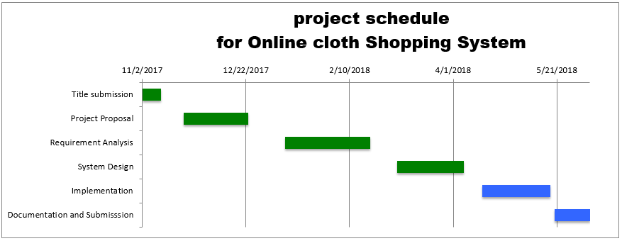

Figure 1 :Project Schedule

### Project Budget

Resources like time and equipment are needed for any system development. Some of resources needed for project team are listed below with their estimated cost.

|  |  |  |  |  |  |
| --- | --- | --- | --- | --- | --- |
| **No.** | **Item Description** | **Quantity** | **Unit** | **Unit Price** | **Total price** |
| **1** | Removable flash disk | 2 | Birr | 250.00 | 500.00 |
| **2** | Blank CD | 5 | Birr | 6.00 | 30.00 |
| **3** | Binding | 2 | Birr | 20.00 | 40.00 |
| **4** | Paper | 1 pack | Birr | 70.00 | 70.00 |
| **5** | Pencil | 4 | Birr | 1.00 | 4.00 |
| **6** | Pen | 10 | Birr | 5.00 | 50.00 |
| **8** | Printing | 3 | Birr | 50.00 | 150.00 |
| **9** | Laptop (pc) | 1 | Birr | 13,000.00 | 13,000.00 |
| **Total** |  | | | | **13,844.00** |

Table 1: Project budget

### Project Work Breakdown

In project team every task must be done by every person of the group, so the group participates on every stage of planning, analysis, and design of this project by sharing ideas. Since entire member of the team exist at the same level or responsibility to do the project, for reviewing each other work, to reduce time consumption, to make the member fully knowledgeable & to increase the project quality, project group organization is based on decentralized control Team organization.

|  |  |  |  |  |  |
| --- | --- | --- | --- | --- | --- |
| Project Title | **ONLINE CLOTH SHOPPING FOR**  **DOYA COLLECTION** | | | | |
| **PROJECT BREAKDOWN** | **No** | **Name** | **Id No** | **Mob. Phone** | **Responsibility** |
| 1 | Geleta Begna | EISR/0054/07 | 0925922030 | All members |
| 2 | Hawi Feyisa | EISR/0058/07 | 0962067743 | All members |
| 3 | Asnaku Nagashu | EISR/015/06 | 0921210550 | All members |
| 4 | Mustefa Kedir | EISR/0067/07 | 0922702972 | All members |

Table 2 : Project breakdown

### Risk Analysis, identification, mitigation and monitoring

#### Risk

* Virus attacks the file used for development.
* There may be holy days and vacations to miss the project activity days.
* The developing tools may not exist or live out.
* The internet may not available in the campus.
* The developing tools may increase cost or cost variation.
* There may some conflict in our country.

#### Mitigation

* Data loss happens, so the team uses different back up techniques through our daily activity in the project.
* The development tools not working so re-configure the setup.
* Impossible to continue without development tools so we may buy tools depend on condition necessity.
* It is difficult for project team but buy tools at immediate in the development time.
* There may be no Wi-Fi connection in the campus. So use mobile data to get some additional information or guide from the internet.

## Feasibility of the project

### 1.7.3. Economic Feasibility

To identify the economic feasibility of the project the team has done cost-benefit analyses which enable the team to specify the benefits and costs associated with the project. The following work sheets specify the costs as well as benefits associated with the project.

**Intangible benefits:** The following worksheet lists the intangible benefits associated with the project.

Intangible Benefit

1. Increase Employee Morale
2. Reduce Resource Consumption
3. Increase Management flexibility
4. Provides more timely information

**Tangible benefits:** The team calculated the corresponding tangible benefits based on the technique called the Time Value of Money (TVM).

**1. Cost Reduction andAvoidance**: - To calculate these following things will be considered. Total Number of Employee in existing system= **2**

Average Salary of each Employee per month = **1000.00Birr**

Total money required for payment per year= **2*1000*12= 24,000.00Birr**

Average Number of Employee needed when the new system is deployed= 1

Average salary per month = **1200.00Birr**

Total money required for payment per year= **1200*12**= **14,400.00Birr**

Difference b/n before and after deployment money required for payment

Cost Reduction and Avoidance= 24,000.00**Birr-14,400.00Birr= 9,600.00Birr**

### Technical Feasibility

The entire group members are expected the system to be technically feasible. The system we are going to be developed by technological development technique such as PHP, java script, CSS. And the team has the ability to develop this system without any difficulty since the team has studied the required methodologies and tools. So the system will be technically feasible.

### Political Feasibility

The system behaviourally feasible cannot cause any harm to the shop. The system was developed user friendly and improves the working of shop. It gives services for the customers effectively and efficiently. So the customer and owner is profitable and the system will be politically feasible

### Operational Feasibility

The entire team member, expect that the system which is in development is to be operational. That is once the system is deployed, it can operate on any of the operating systems. Therefore, the system will be designed to be operationally feasible that if it is deployed, the system will operate in any kind of platforms without any mal functionalities.

# CHAPTER 2

# CURRENT SYSTEM

## Introduction

The current system is not provide goods and services online and has not provide online payment system, to their purchased items. And also no anyway of method and awareness on preparing report and receipt. They simply selling and purchasing items to their customers and only generate the day to day income of the shop. The activity of the retailer is selling the items dealing within a customer.

## Description of the current system

It is necessary to know the existing system of a given organization to develop a better system. Existing system currently performs different activities including registering new users, reservation, maintain and update records, prepare report in manually. The shop is located at distance about 1KM from the Madda walabu University to the east-west direction of the Robe city in front of Waqo Gutu square.

## Drawback of the existing system

The existing system actually faces to a lot of problems, and these problems results due to the manual system of accomplishing its operations. Records about any activity in the store are kept manually. Records about item, user, and employees are also kept manually on registers and records which are alphabetically arranged in a wooden box. This may result in the data lost.

Since all records kept physically on shelves and file cabinets the shop record keeping system is poor and subjects to number of problem:

* There is no means of keeping backup

Since records kept in manual or on shelves it use more space7

* There is also loose of physical recordings through times
* Helpless to misplacement of the record

**Registration related problems**

Registering users and newly acquired information source is manual and not well organized .This in turn will result in poor techniques handling information related. Such as

* Difficult to integrate data from different individual records
* Unable to interest different user request.

Therefore these stated problems make the performance of the existing system unsatisfactory.

Regarding to the information, the current system or the existing system has lack of the information in terms of timeliness, accuracy and format.

Regarding the economic benefit of the system being proposed, its directly related to the performance, as performance increases number of customers also increases which brings significant economic benefit to the shop as opposed to the existing system performance which is low and this will make users unsatisfied and brings to a decrease of customers and also loss of income, so the existing system is not a walk in the park.

The existing system also have problems in terms of controlling and managing all documents of the registered new items and the daily and monthly report of the business perfectly, as days increase, the items and the customers will increase and the documents also increase so it will be out of control to manage the documents.

The efficiency of the existing system could be evaluated in terms of the profitability of the shop that comes from all the items which are sold to the customers and by increasing the number of customers by satisfying their market approach. But as we explained in above problems, the overall efficiency of the existing system is not stable or as a general it is not efficient.

Because the shop is using the manual system there is a problem in giving the service to the customers. To mention some of the problems of the existing system,

* Need of high energy and time for selling products because of its low ability to serve many customers at a time.
* Inability to give the service to more than two customers at a time.
* The numbers of employees needed to handle the customers are limited.
* It takes lot of time to calculate price of each items and serve many customer at the same time.
* Location of existingshop is not attractive.
* Poor customer satisfaction.

## Practice to be preserved from the current system

The list of the preserved practices from the existing system stated below.

* The way of attracting the customer towards the market with good approach.
* It takes part of the workers day to day activities in the shop to be self-independent.
* Controlling and registering the items when they come into the store
* System procedure

## Business Rule

A business rule is effectively and working principle or polices that we try to specify for both the existing system and the new system must satisfy. The business rule is a principle or a policy in which the proposed system works accordingly. It deals with access control issues.

Our proposed system includes the following working principles or rules:

* Business Rule1:Customer should have valid credit card number
* Business Rule2: The customer fills the form properly.
* Business Rule3: The system gives fast responses to the customer.
* Business Rule4: The system should work 24 hours and 7 days per a week.
* Business Rule5: The Shop should give services to both registered and unregistered customers.
* Business Rule6: Do not try to registered again within the same user name

## Alternative solution

As we try to describe above, the existing system faces problems and the problem’s primarily resulted from the manual system of running the activities and we try to put an alternative solution to the problems which are described in the above problem identifying in the existing system section.

* The best alternative solution to the existing system is to change the existing manual system and producing an electronic (online) system.

# 

# CHAPTER 3

# Proposed system

## Overview of the proposed system

The proposed system is concern about the Online Cloth Shopping System in order to provide an alternative solution for the shop. For doing activities of the Online Shopping System such as recording purchased and sold items and generating transaction of it. And also these new systems protect and secure the Online Shopping System data files in secured way.

## System constraints

The following requirements are general constraints of the system:

* The system operates only in English language
* It’s not suitable for disable person, like blind people.
* It needs some computer skill to operate on the system.

## Functional Requirement

## Functional requirements are descriptions of activities and services a system must provide.

The new system is expected to provide the following functionalities:

* **Customer Registration**: - The system will register the user, and the registered user   
   will be benefited over the unregistered one. So users registered to the system by filling the information provided to him.
* **Order management**: - The user order the products by simply clicking on add to cart.
* **Feedback mechanism (comment)**:- The system will accept comment.
* **Online Payment :-** The system supports payment, after user’s add product to cart.
* **Managing product**: - through this system an administrator can manage the order sent to him/her by the customers.
* **Managing users**: - Administrator can manage user accounts.
* **Login**:-Users logins to the system by entering valid user id and password for the shopping. This is just for the authentication. This system will work on client-server architecture. It will require server and which will be able to run PHP application. The system should support some commonly used browser such as IE, Mozilla Firefox Google chrome and such like.

## Non-functional Requirement

The following lists of non-functional requirements are expected from the system:

* **Scalability**: The system must be compatible with any environment.
* **Security**: should allow login to only authorized users
* **Performance**: this system gives service 24 hours per day with maximum response time so, it is easy to access data from the stored document.
* **Accuracy:** proposed system will be better due to reduction of error. All operation can be done correctly and it ensures that whatever information is coming from the data base is accurate.
* **Reliability:** The reliability of the proposed system will be better due to proper storage of information when users access the application.
* **No Redundancy:** In the proposed system can be avoided repetition of data anywhere in the database.
* **Availability:** All data in the system will be available all the time.
* **User friendly Interface:** Users can easily input and retrieve their profile and history.
* **Error handling Exception**: The system must recover immediately when a user enters incorrect (error) data.
* **Backup and Recovery**: When team member stand to develop a system they must have to use a backup mechanism by using removable flash disks or CDs. Because the data might lose due to computer viruses or power fluctuation.

## Graphical user interface



Figure 2:User interface

### Specification

Specification is the action of specifying a detailed description of the design and materials used to make describe of something an invention accompanying an application in graphical user interface.

**Customer Page**: - Someone who buys product

**Administrator Page: -** Aspecial user of the system who can setup access right for other users.

* Manage user: - Responsible for add user, update user and delete user.
* Manage account: - Add account, update account and delete account.

**Sign in Page:**The customer can login to the shopping system by entering his username and password. The system will verify that the login name matches the login password. If they do not match, error message will be indicated to the customer.

**Registration Page:-**If the customer is a new user, he can request to register with the system. The system displays a registration page and asks the customer to choose a login name and password. The customer is also required to enter their name and address.

### User interface description

The goal of user interface design is to make the user's interaction as simple and efficient as possible, in terms of accomplishing user goals. When designing the home page we use master page to each activities in module that is admins activity must be moduli zed in one master page and style sheet is used to design each form and in this style sheet we use header, menu and aside static part and section that is everything is on it.

## Hardware and software Requirements

A) Hardware requirement

* Laptop or Computer
* RAM size 4 GB or more
* Processor speed 2.5 GHZ or more

B) Software requirement

* Mozilla Firefox
* Baidu browser

## Security and safety procedure

Security of the system must be given the outmost consideration in a database intensive system, to make authentication of users and authorization on and incorporate functionality that the system need to have:

* All the system must be secured: Administrator must be able to give right or deny   
  for all user based on his or her position by the administration of the system.
* All major transaction of the system should be logged to database and seen only by the administrator.
* The system has session control: When the user registered once the system can save the user data.

# 

# CHAPTER 4

# System modelling

## Introduction

The system modelling deals with analysing the proposed system. It includes the system use case diagrams, the use case descriptions (scenarios), sequence diagrams, and activity diagrams. After identifying the actors and use cases, the use cases are developed and textual descriptions(Scenarios) are stated. The Sequence diagram is depicted based on the use cases which are developed for the proposed system. Activities can be represented by the activity diagrams.

## Systemise case diagram

A use case diagram is a dynamic or behaviour diagram in UML. Use case diagrams model the functionality of a system using actors and use cases. Use cases are a set of actions, services, and functions that the system needs to perform. In this context, a "system" is something being developed or operated, such as a web site. The "actors" are people or entities operating under defined roles within the system.(smartdraw, n.d.)



Figure 3: System Use case Diagram

### Actor description

* **Customer:** performs activities login, Use shopping cart, payment, manage profile and order Item.
* **Visitor:** performs activities like View Product, Use shopping cart, payment, order Item.
* **Administrator:** performs activities like login, add Item, add category, Add warehouse, update item, delete item, view item.

### Use case description (scenario)

|  |  |
| --- | --- |
| Use case name | Login |
| Primary actor | Administrator and Customer |
| Precondition | A user must have an account to login |
| Basic flow of event | 1. System displays login home page.  2. User enters username  3. User enters password.  4. Click login button. |
| Alternative Action | If username and password is wrong system will display error message.  Then go to step 2&3. |
| Post condition | System displays login successfully. |

Table 3:Description for login use case

|  |  |
| --- | --- |
| Use case name | Feedback (post comment) |
| Primary actor | Administrator, customer and Visitor |
| Precondition | Any user must browse the website. |
| Basic flow of event | 1. User must open the home page.  2. System displays comment box.  3. Type on a comment box.  4. Click the submit button. |
| Alternative Action | If they went to view the comment the can see it. |
| Post condition | System displays your comment successes. |

Table 4: Description for comment use case.

|  |  |
| --- | --- |
| Use case name | Make purchase (order product) |
| Primary actor | Customer |
| Precondition | The customer should login to system. |
| Basic flow of event | 1. Customer view items.  2. Customer browses or searches the product from the product catalogue.  3. Select product they want from product catalogue.  4. Add selected product to shopping cart.  4.1 Can update the quantity of the product inside the cart.  4.2 Can add another product to cart.  4.3 Can delete the product from the cart.  4.4 Can view the details of product inside cart.  5. Click on purchase order button. |
| Alternative condition | If the customer should not fill form correctly the system will display  message to re-correct and go to the setp2. |
| Post condition | System acknowledges the product is successful ordered. |

Table 5: Description for make purchase use case

|  |  |  |
| --- | --- | --- |
| Use case name | Manage ordered product | |
| Primary actor | Administrator | |
| Precondition | Admin should login first and there should be at least one order in the database. | |
| Basic flow of event | 1. Customer send ordered items.  2. Administrator view the ordered report and confirm report.  3. Finally, Employee promote product to customers physically. | |
| Alternative condition | If there’s no any transaction, process can be cancelled. | |
| Post condition | | System acknowledges the success update of the order. |

Table 6: Description for manage order use case

|  |  |
| --- | --- |
| Use case name | Manage product |
| Primary actor | Admin |
| Precondition | Admin should login |
| Basic flow of event | 1. Admin browse home page.  2. Login to the system.  3. Go to product page.  4. Upload product details.  5. Click on add button if the product is new.  6. Modify product from the list if the product old by clicking on update  button.  7. Add the quantity of the product.  8. Logout inside the system. |
| Alternative condition | If the product information is not correct the system displays the message  to correct the information. |
| Post condition | System acknowledges updating product is successfully completed. |

Table 7: Description for manage product use case

|  |  |
| --- | --- |
| Use case name | Manage information |
| Primary actor | Administrator, customer |
| Precondition | Any user should be login first. |
| Basic flow of event | 1. User can request update info.  2. User enters personal information to the provided form.  3. User input will be saved to database.  4. User can add, delete or modify its information.  5. Submit the updated information by clicking on updated button. |
| Alternative condition | If the user enters incorrect information system back step1. |
| Post condition | System will displays updated info successfully stored in database. |

Table 8: Description for update information use case

|  |  |
| --- | --- |
| Use case name | Registration |
| Primary actor | Visitor |
| Precondition | No |
| Basic flow of event s | 1. User open home page.  2. Click on the register button.  3. System displays the form.  4. User fills the form.  5. User click on signup button. |
| Alternative Action | If the user didn`t fill the form correctly the system notifies  to enter information again |
| Post condition | The system acknowledge successfully is registered |

Table 9: Description for create registration use case

|  |  |
| --- | --- |
| Use case name | Generate report |
| Primary actor | Employee ,admin |
| Precondition | Customer must send order |
| Basic flow of event | 1. Admin receive request  2. Admin view report and check items.  3. Admin confirm the report. |
| Alternative Action | If item is not there admin remove report or does not confirm report. |
| Post condition | System displays report is successfully send. |

Table 10: Description for generate report use case

## . Dynamic modelling

### Sequence diagram

Sequence diagrams describe interactions among classes in terms of an exchange of messages over time. They're also called event diagrams. A sequence diagram is a good way to visualize and validate various runtime scenarios. These can help to predict how a system will behave and to discover responsibilities a class may need to have in the process of modelling a new system.(smartdraw, n.d.)

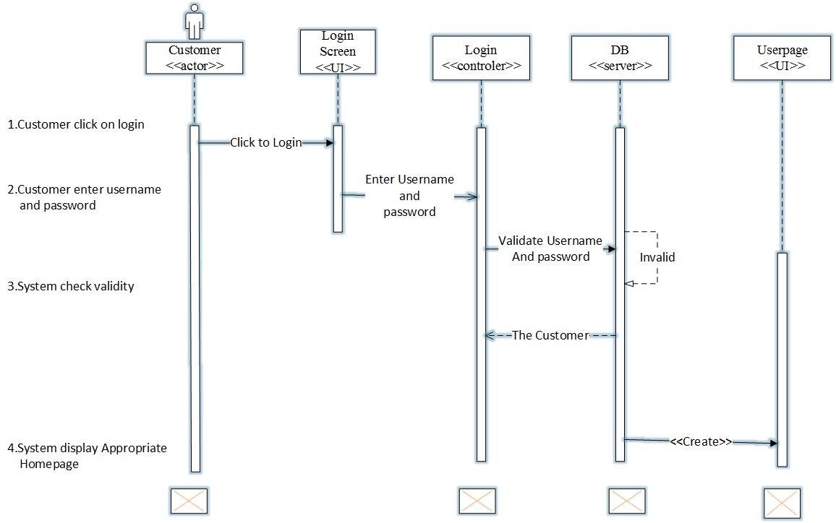

Figure 4:Sequence diagram for login

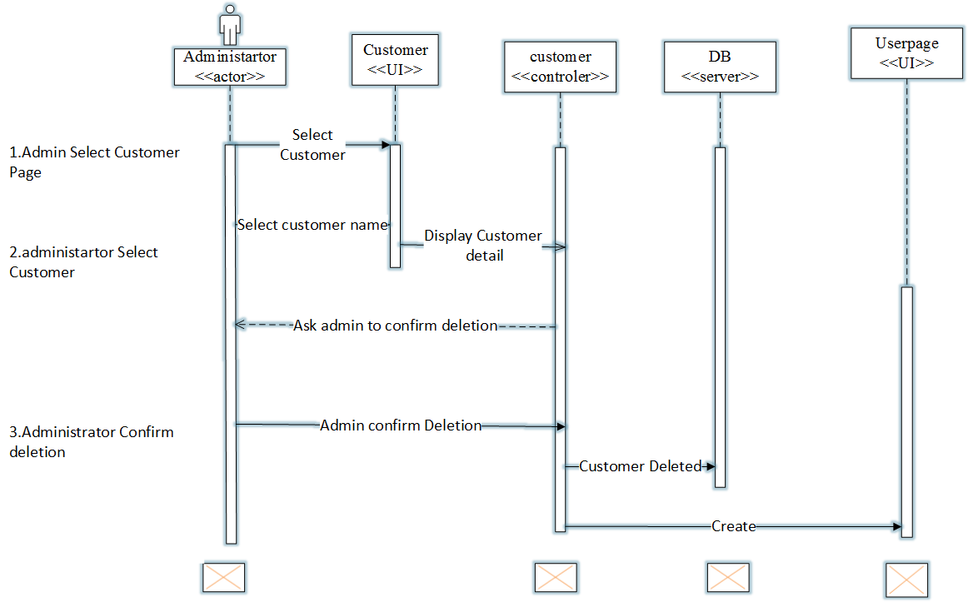

Figure 5:Sequence diagram for Delete Customer

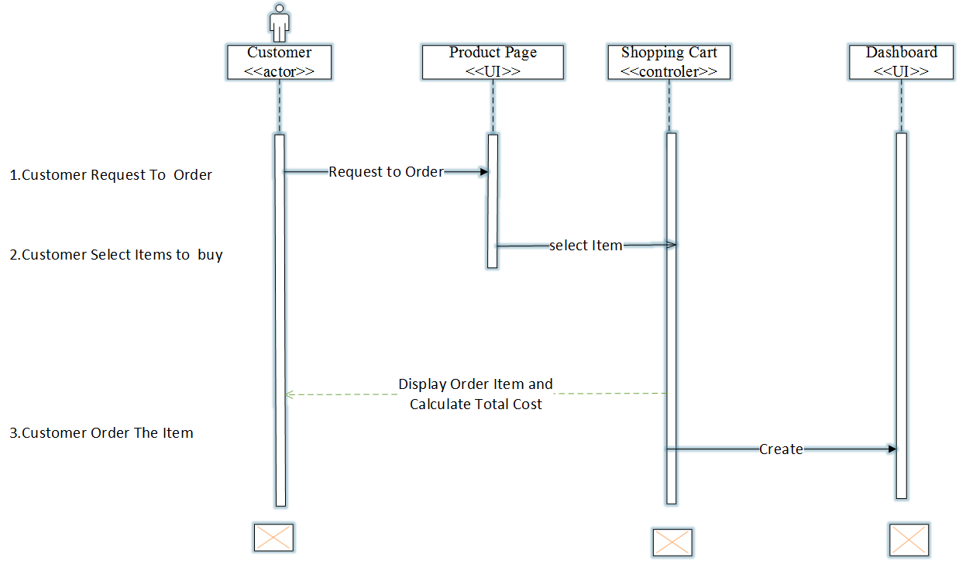

Figure 6:Sequence diagram for order item

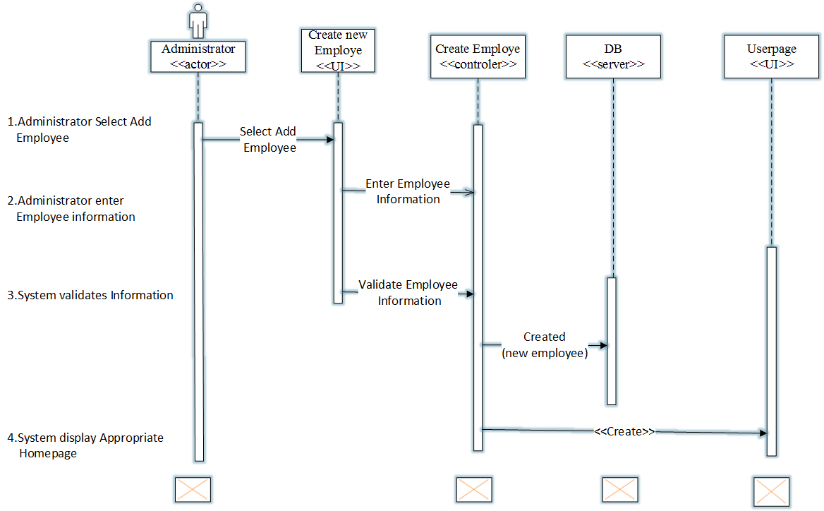

Figure 7:Sequence diagram for Create Employee

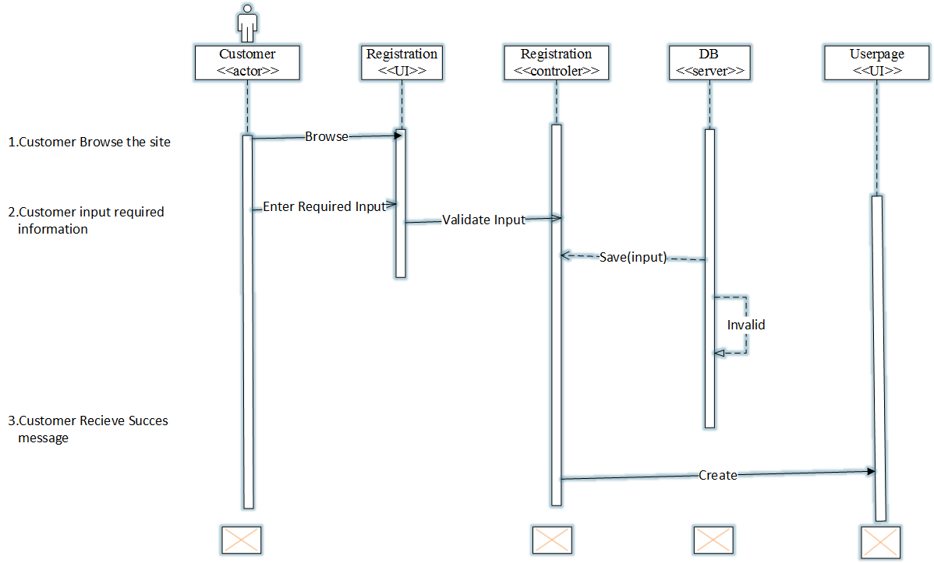

Figure 8:Sequence diagram for registration

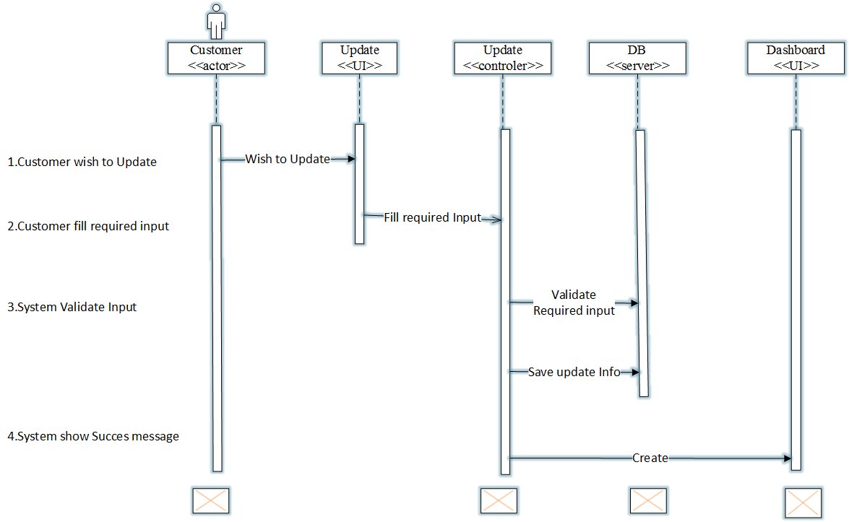

Figure 9:Sequence diagram for Update Customer

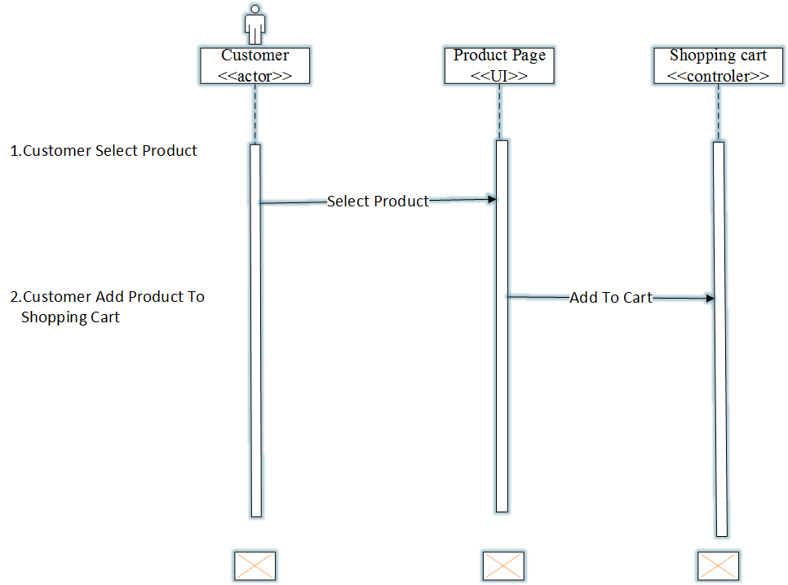

Figure 10:Sequence diagram for Add Item to Cart

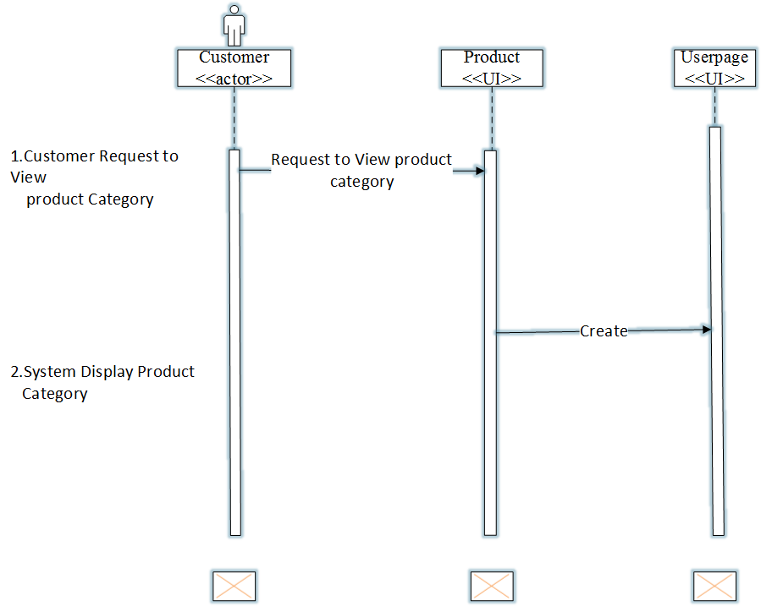

Figure 11:Sequence diagram for Browse Product

4.4. Activity diagram

Activity diagram is another important diagram in UML to describe the dynamic aspects of the system. Activity diagram is basically a flowchart to represent the flow from one activity to another activity. The activity can be described as an operation of the system. The control flow is drawn from one operation to another. This flow can be sequential, branched, or concurrent.

The basic purposes of activity diagrams is to capture the dynamic behaviour of the system. Other diagrams are used to show the message flow from one object to another but activity diagram is used to show message flow from one activity to another.(tutorialspoint, n.d.)

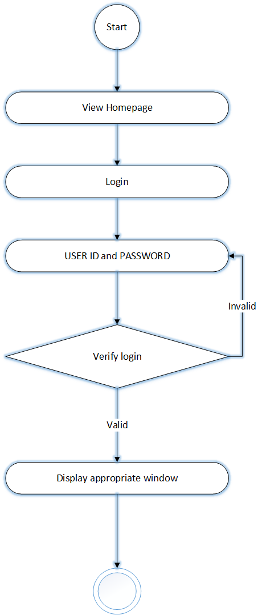

Figure 12:Activity diagram for login

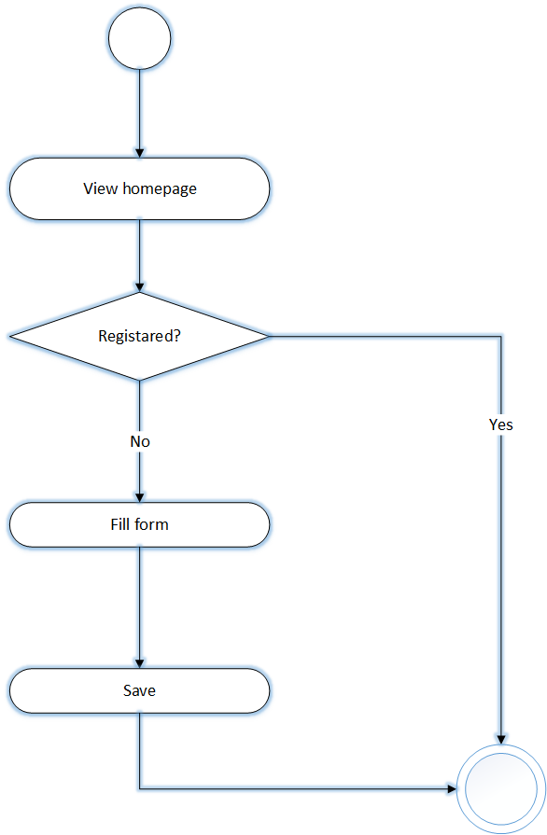

Figure 13:Activity Diagram for registration

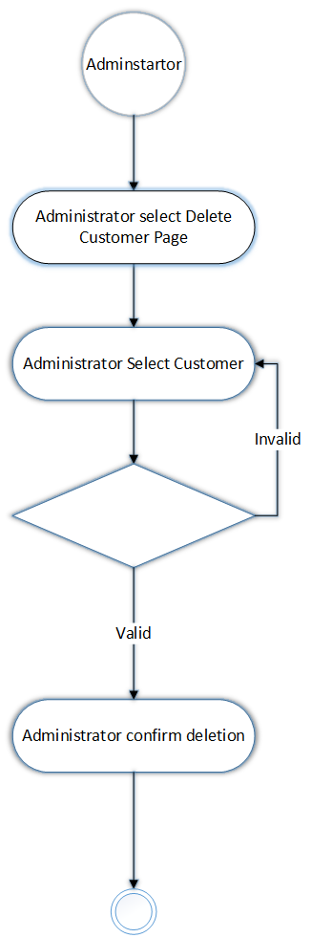

Figure 14:Activity Diagram for Delete Customer

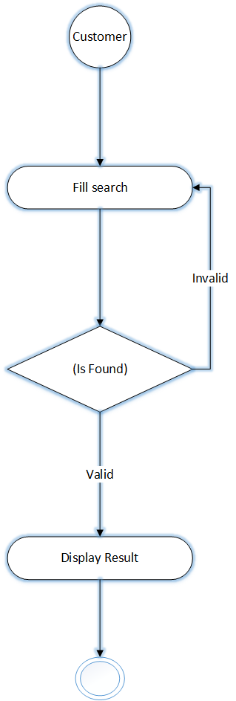

Figure 15:Activity Diagram for Search item

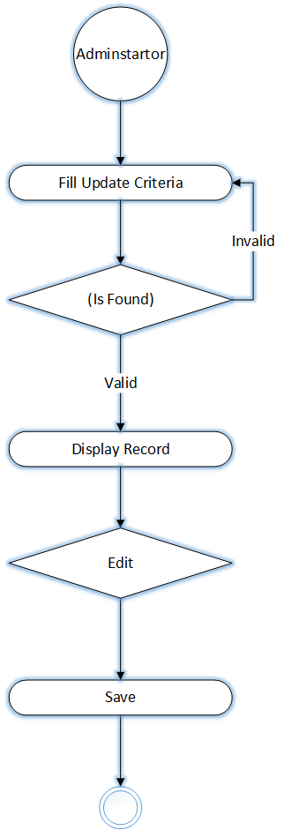

Figure 16:Activity Diagram for Update item

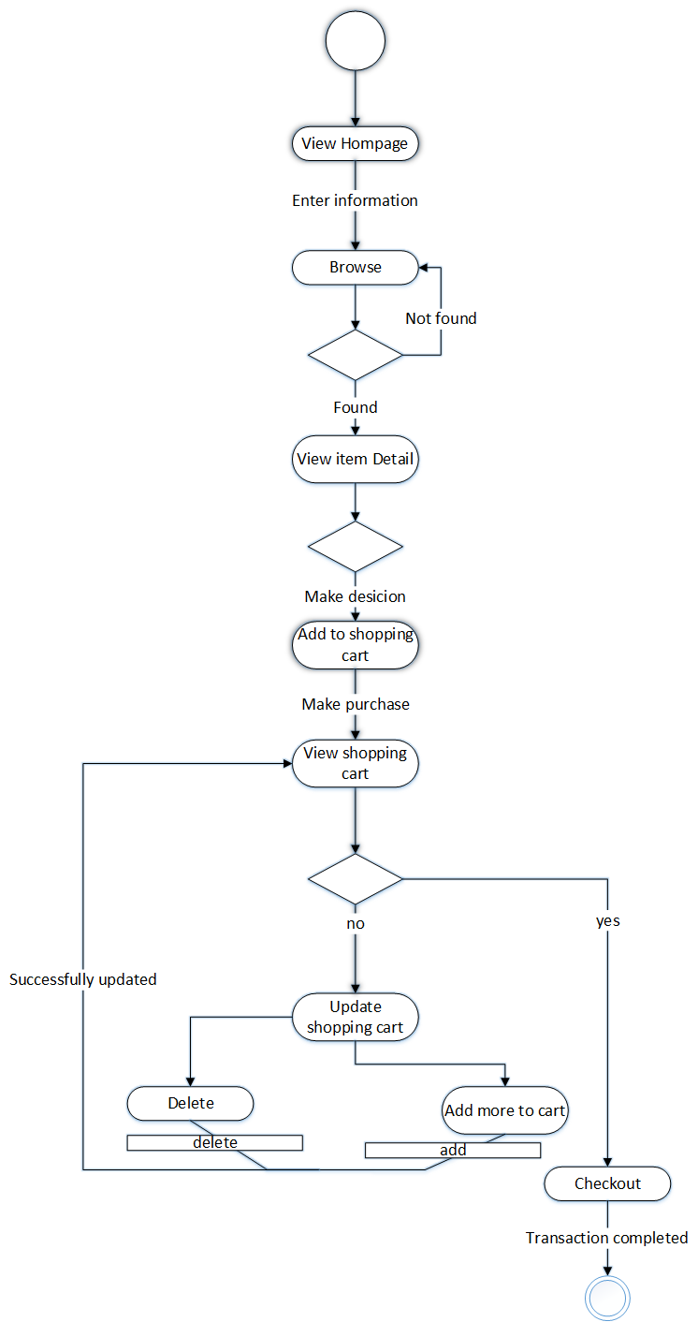

Figure 17:Activity Diagram for View item and Make Purchase



Figure 18 : Activity Diagram for Add item



Figure 19:Activity diagram for Delete Customer

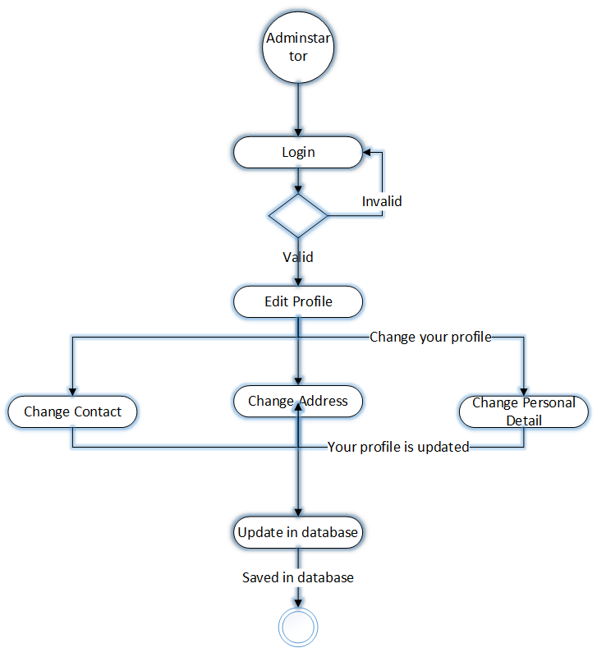

Figure 20:Activity Diagram for Manage Information

# CHAPTER 5

# System Design

## Introduction

This project is designed in a manner that solves the problems of the organization by minimizing the work load that appears on the employees because of the existing manual system. It provides more efficient, reliable and time saving system. In this project design the team will try to show:

* How the project is designed
* What are tasks done under the whole project
* The different modules and their way of functioning are described here.

Generally, the project will be designed by addressing all of the above criteria of project design. It is designed to simplify functions of the manual system and it is capable of doing large amount of works in short period of time with more accuracy and reliability. Generally this project design will describe how the project is designed, what tasks done under this project and different modules and their way of functioning.

We expect one can understand our new system implementation because it gives full description about whole system. Also one can understand easily and enable to answer how the system developed and functioned in simplified manner.

The goal of system design according to the proposed project is to manage complexity by dividing

the system into smaller, manageable pieces and to increase the system:-

* Efficiency: the system doing something well and thoroughly without waste of money and time.
* Flexibility : the system able to change to suite new condition or situation
* Security: the system should be secured, i.e. not allow unauthorized users to access the system.
* Reliability: the system should be reliable.

## Class diagram

A class diagram models the static structure of a system. It shows relationships between classes, objects, attributes, and operations.(smartdraw, n.d.)

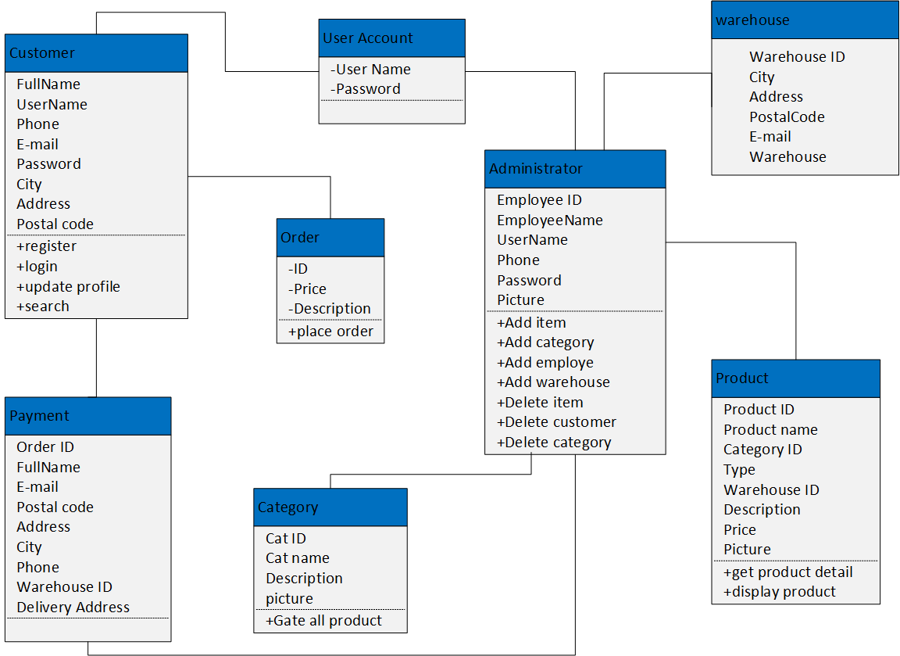

Figure 21: class diagram

## State chart diagram

The state chart diagram used to show the sequence of states that an object goes through the events that cause the transition from one state to the other and the actions that result from a state change.

### 5.3.1 State chart diagram for login

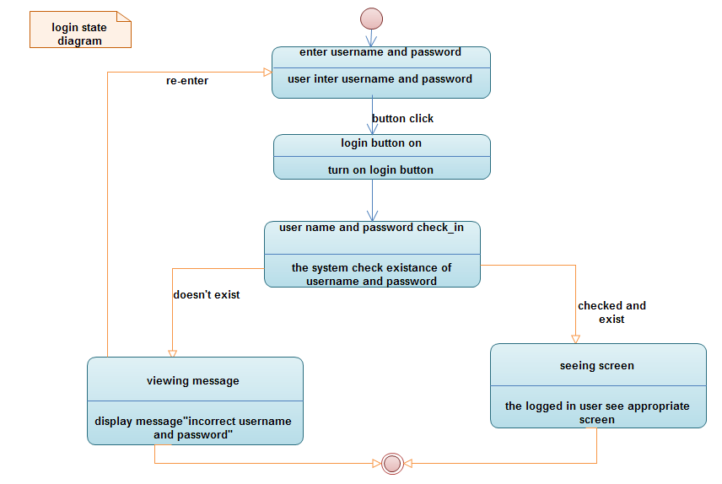

Figure 22: State chart diagram for login

### 

### 5.3.2 State chart diagram for new customer registration

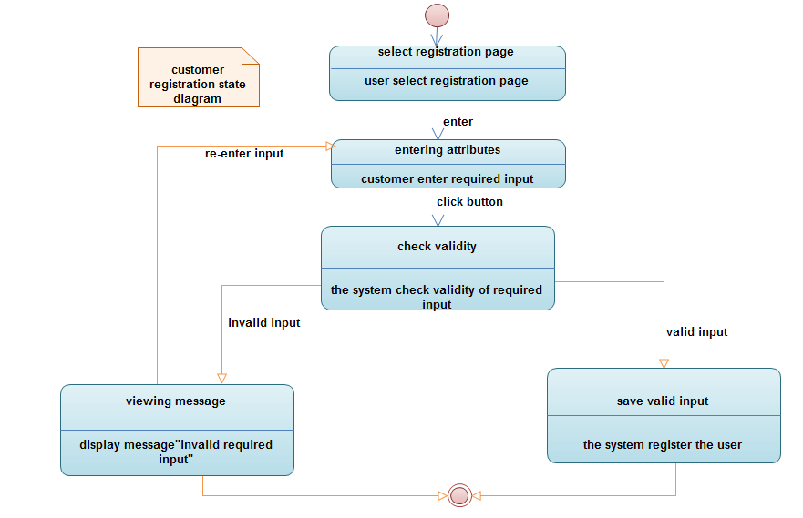

Figure 23 :State chart diagram for new customer registration

### 5.3.3 State chart diagram for delete customer

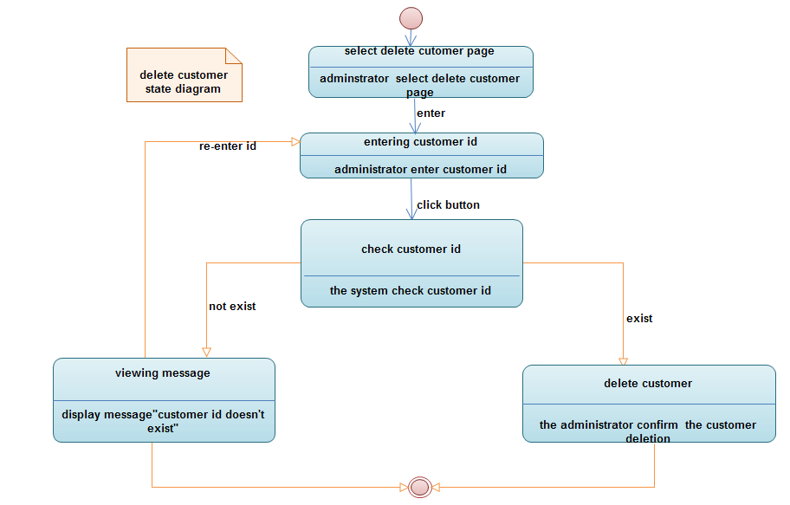

Figure 24: State chart diagram for delete customer

### 5.3.4 State chart diagram for update customer information

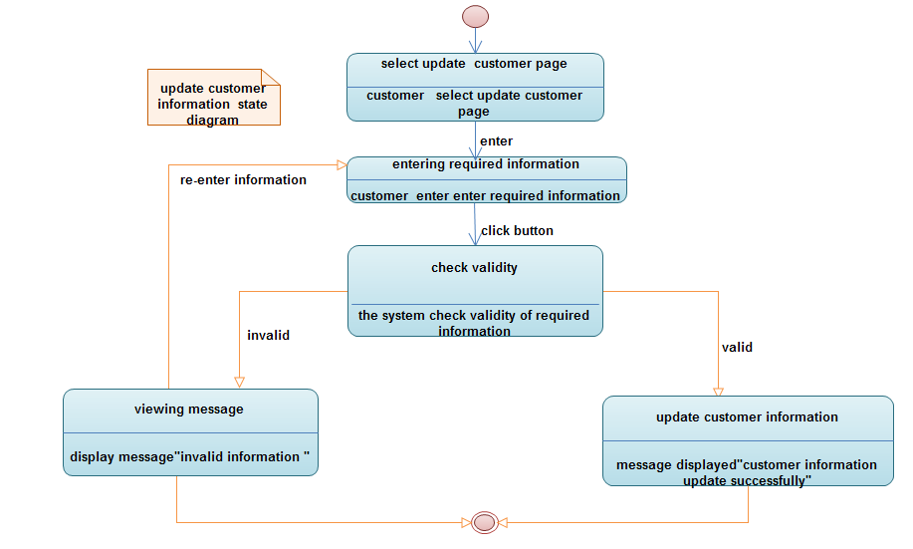

Figure 25: state chart diagram for update customer information

### 5.3. State chart diagram for browse product

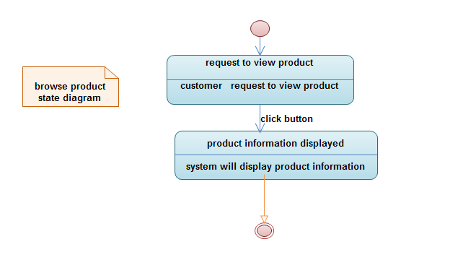

Figure 26: State chart diagram for browse product

### 5.3.6 State chart diagram for order product

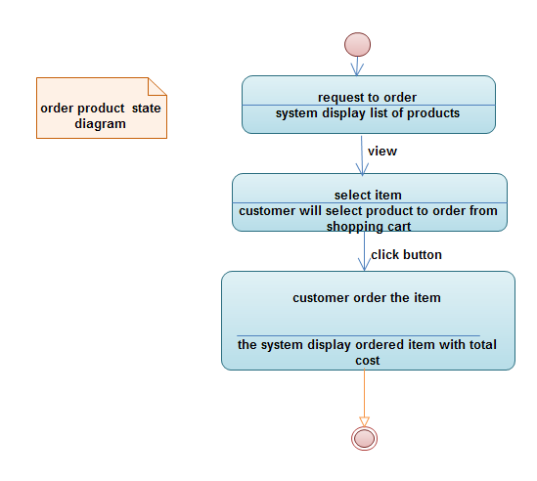

Figure 27: State chart diagram for order product

### 5.3.7 State chart diagram for add item to cart

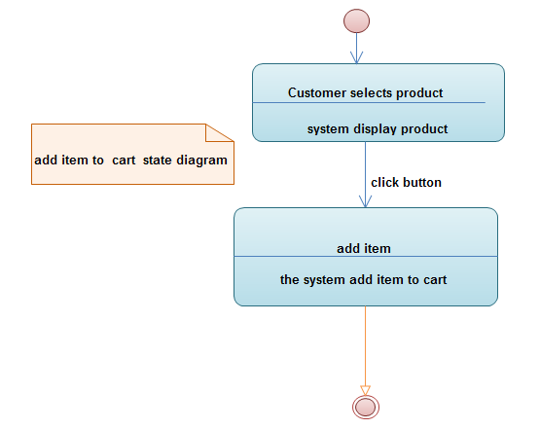

Figure 28 State chart diagram for add item to cart

### 5.3.9 State chart diagram for payment

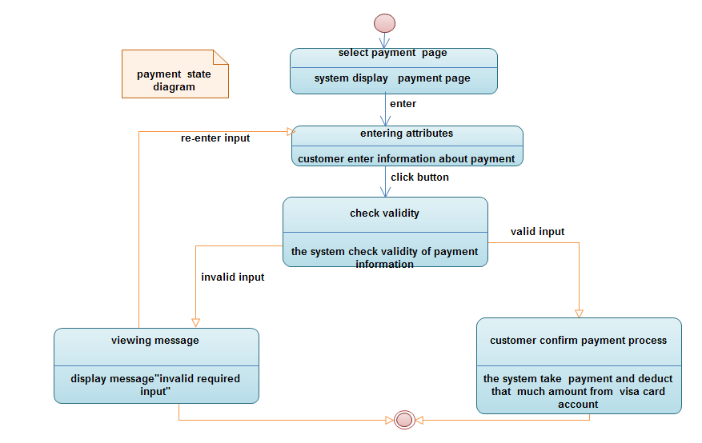

Figure 29 State chart diagram for payment

## Collaboration diagram

A collaboration diagram is an illustration of the relationships and interactions among objects in the unified modelling language

### Collaboration diagram for system login

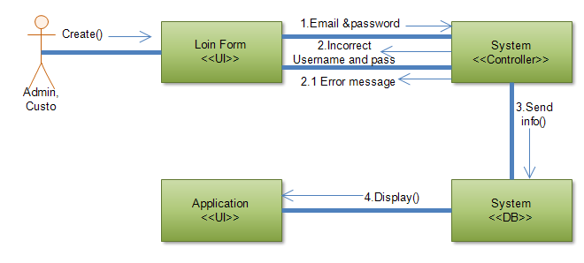

Figure 30:Collaboration diagram for system login

### Collaboration diagram for customer registration

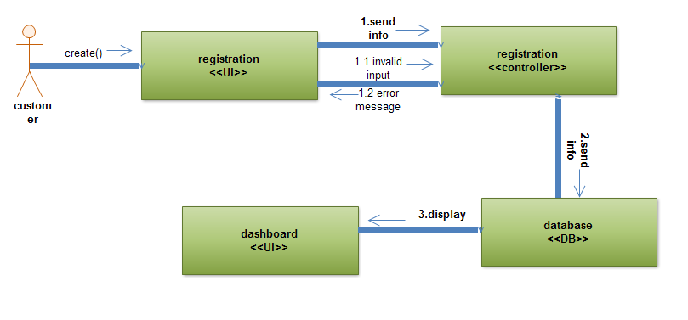

Figure 31:Collaboration diagram for customer registration

### Collaboration diagram for delete customer

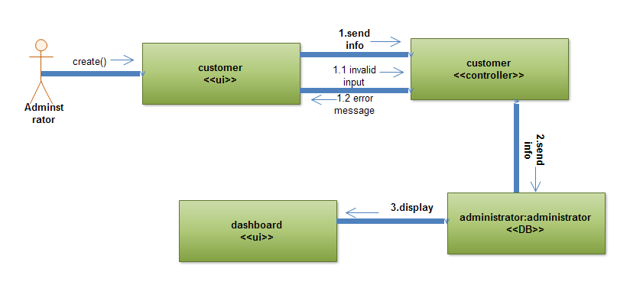

Figure 32:Collaboration diagram for delete customer

### Collaboration diagram for update customer information

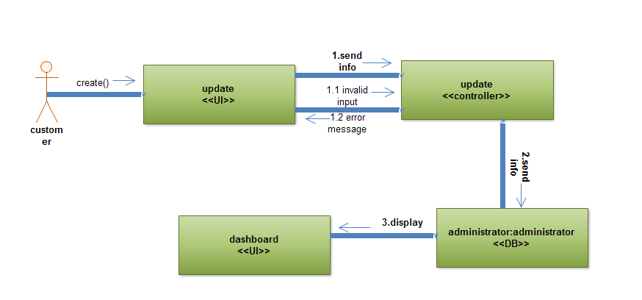

Figure 33:Collaboration diagram for update customer information

### Collaboration diagram for browse product

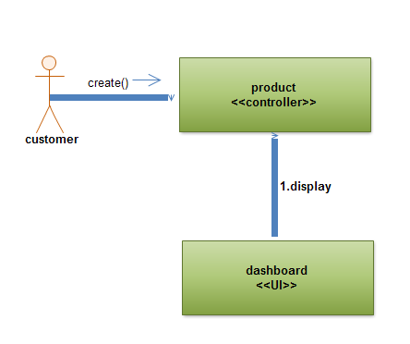

Figure 34:Collaboration diagram for browse product

### Collaboration diagram for order product

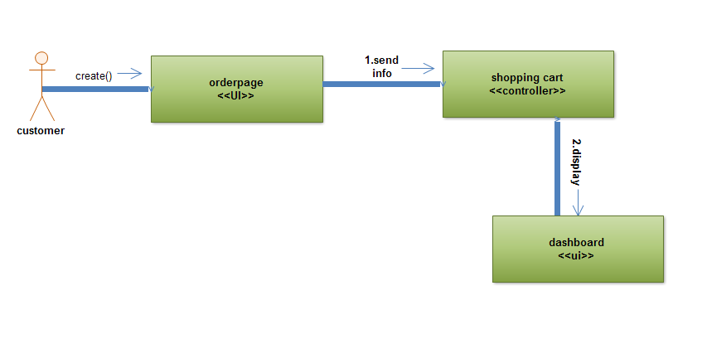

Figure 35:Collaboration diagram for order product

### 5.4.7 Collaboration diagram for add product to shopping cart

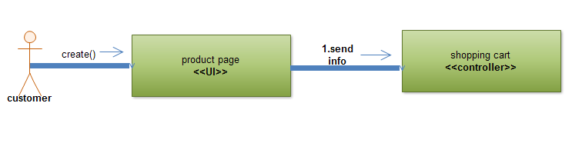

Figure 36:Collaboration diagram for add product to shopping cart

5.4.8 Collaboration diagram for add product to catalog

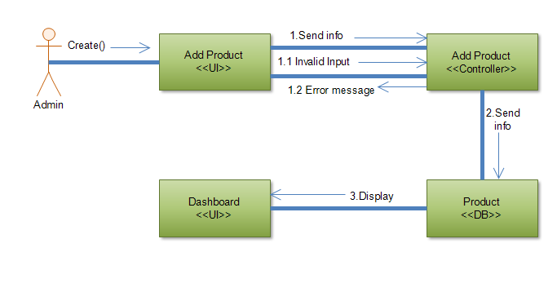

Figure 37: Collaboration diagram for add product

### 5.4.9 Collaboration diagram for Delete product from catalog

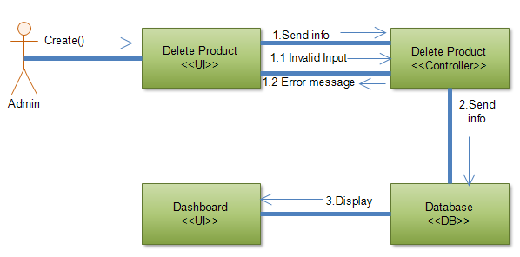

Figure 38:Collaboration diagram for Delete product from

### 5.4.10 Collaboration diagram for payment

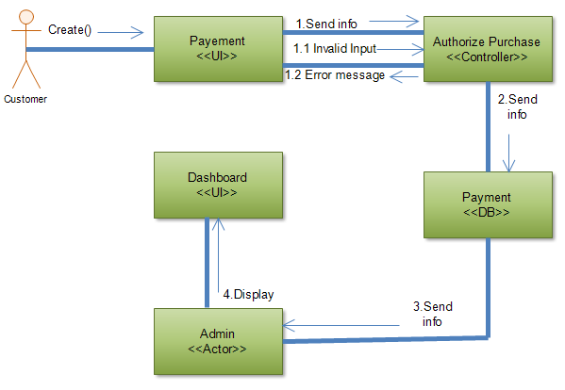

Figure 39:Collaboration diagram for payment

## Component Diagram

Component diagrams are different in terms of nature and behaviour. Component diagrams are used to model the physical aspects of a system. Physical aspects are the

elements such as executable , libraries, files, documents, etc. which reside in a node. 

Figure 40: Component Diagram

## Deployment diagram

Deployment modelling is used to show the hardware of the system, the software that is installed in the hardware and also the middleware that is used to connect the disparate machines to one and other. It also shows how the software and the hardware components work together.



Figure 41: Deployment diagram

## Database design

Database design is the process of producing a detailed [data model](http://en.wikipedia.org/wiki/Data_model) of a [database](http://en.wikipedia.org/wiki/Database). This [logical data model](http://en.wikipedia.org/wiki/Logical_data_model) contains all the needed logical and physical design choices and physical storage parameters needed to generate a design in a [Data Definition Language](http://en.wikipedia.org/wiki/Data_Definition_Language), which can then be used to create a database. A fully attributed data model contains detailed attributes for each entity.



Figure 42:Database design

## ERD design

An entity-relationship diagram is a data modeling technique that creates a graphicalrepresentation of the entities, and the relationships between entities, within an information system. The Entity Relationship Diagram is shown in the figure 43 below.



Figure 43: ER Diagram

## Normalization

### First Normal Form

|  |  |  |  |  |  |  |
| --- | --- | --- | --- | --- | --- | --- |
| Account Table | | | | | | |
| Account_ID | | User_name | | password | | |
|  | | | | | | | | |
| Customer Table | | | | | | | | | |
| Cust_ID | Password | | User_name | | email | Address | | city | Account_Id |

|  |  |  |  |  |  |  |
| --- | --- | --- | --- | --- | --- | --- |
| Order Table | | | | | | |
| Order_ID | Email | Address | City | Name | Postal_code | category |

|  |  |  |  |  |  |
| --- | --- | --- | --- | --- | --- |
| Product Table | | | | | |
| Pro_ID | Pro_name | Cat_id | Warehouse_id | Price | Description |

|  |  |  |  |  |  |  |
| --- | --- | --- | --- | --- | --- | --- |
| Payment Table | | | | | | |
| Pay_ID | Email | Address | City | Name | Postal_code | Category |

### Second Normal Form

|  |  |  |  |  |  |
| --- | --- | --- | --- | --- | --- |
| Customer Table | | | | | |
| Cust_ID | Password | User_name | email | address | city |

|  |  |
| --- | --- |
| New Table | |
| Cust_ID | Account_ID |

|  |  |  |  |  |  |
| --- | --- | --- | --- | --- | --- |
| Order Table | | | | | |
| Order_ID | Address | | | City | |
| New Table | | | | |
| Order_ID | | Cus_ID | User_name | |

|  |  |  |
| --- | --- | --- |
| New Table | | |
| Order_ID | Pro_ID | Pro_name |

|  |  |  |  |  |  |
| --- | --- | --- | --- | --- | --- |
| Payment Table | | | | | |
| Pay_ID | Email | Address | City | Name | Postal_code |

|  |  |
| --- | --- |
| New Table | |
| Pay_ID | Account_ID |

### Third Normal Form

|  |  |  |
| --- | --- | --- |
| Customer Table | | |
| Cust_ID | Password | User_name |

|  |  |  |  |
| --- | --- | --- | --- |
| Address Table | | | |
| Cus_ID | State | City | email |

|  |  |  |  |
| --- | --- | --- | --- |
| Feedback Table | | | |
| Cus_ID | Name | Email | phone |

|  |  |  |  |  |  |  |
| --- | --- | --- | --- | --- | --- | --- |
| Payment Table | | | | | | |
| Pay_ID | User_name | | Address | | Postal_code | |
|  | | | | | | |
| Contact Table | | | | | | | |
| Cus_ID | | name | | Email | | phone | |

## 5.10 Object diagram

Object diagrams are derived from class diagrams so object diagrams are dependent upon class diagrams. Object diagrams represent an instance of a class diagram. The basic concepts are similar for class diagrams and object diagrams. Object diagrams also represent the static view of a system but this static view is a snapshot of the system at a particular moment. Object diagrams are used to render a set of objects and their relationships as an instance.

The purpose of a diagram should be understood clearly to implement it practically. The purposes of object diagrams are similar to class diagrams. The difference is that a class diagram represents an abstract model consisting of classes and their relationships. However, an object diagram represents an instance at a particular moment, which is concrete in nature.(tutorialspoint, n.d.)



Figure 44:Object Diagram

## Persistence diagram

Persistent data management deals with how the persistent data is stored and managed and it outlives a single execution of the system. The information related with product, order, user and other related data are persistent and are stored to the database.



Figure 45: Persistence Diagram

## User interface prototype (snap shoot)

User interface design is the overall process of designing how a user will be able to interact with a system. The goal of user interface design is to make the user's interaction as simple and efficient as possible, in terms of accomplishing user goals. When designing the home page we use master page to each activities in module that is admins activity must be moduli zed in one maser page and style sheet is used to design each form and in this style sheet we use header, menu and aside static part and section that is everything is on it.

### Homepage

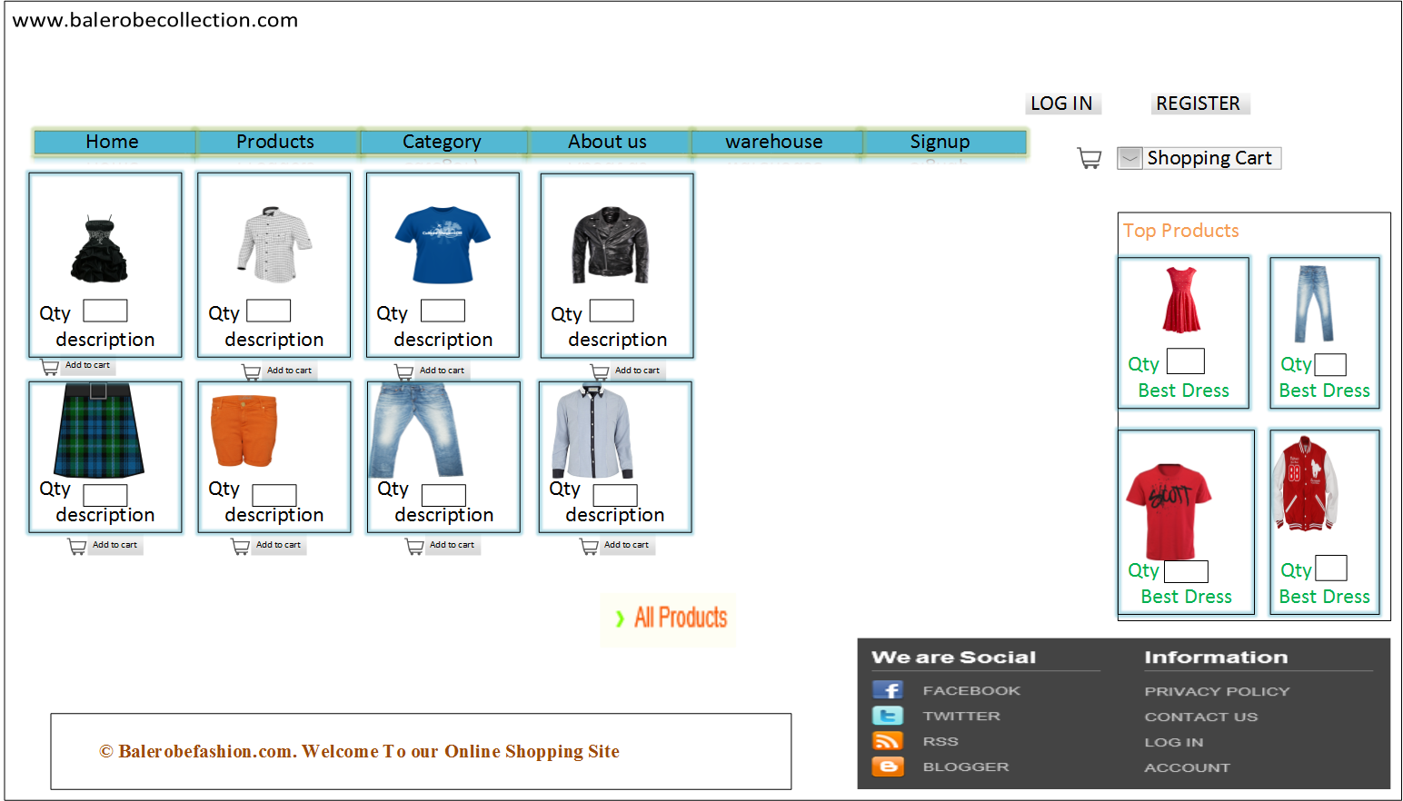

Figure 46: Homepage

### Customer Registration

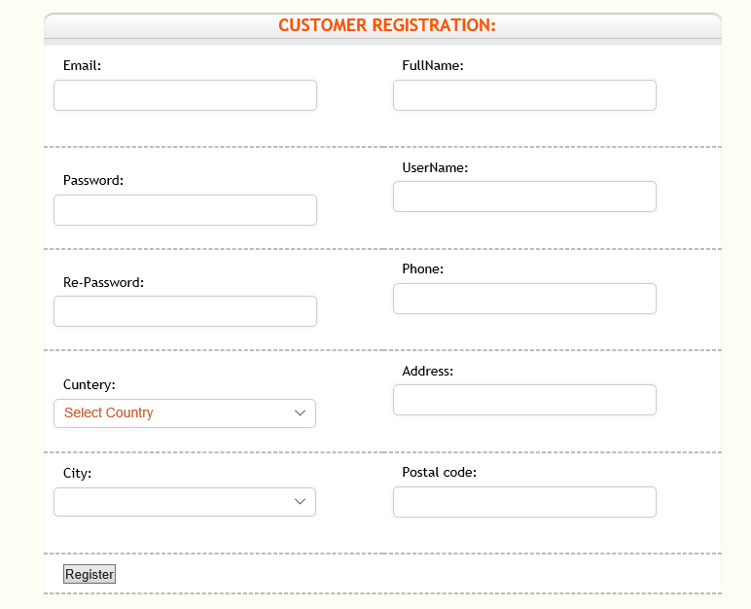

Figure 47 :Registration Page

# 6 References

*smartdraw*. (n.d.). Retrieved from https://www.smartdraw.com/class-diagram/

*smartdraw*. (n.d.). Retrieved from https://www.smartdraw.com/sequence-diagram/

*smartdraw*. (n.d.). Retrieved from https://www.smartdraw.com/use-case-diagram/

*tutorialspoint*.(n.d.).Retrievedfromhttps://www.tutorialspoint.com/uml/uml_activity_diagram.htm

*tutorialspoint*.(n.d.).Retrievedfromhttps://www.tutorialspoint.com/uml/uml_component_diagram.htm

*tutorialspoint*.(n.d.).Retrievedfromhttps://www.tutorialspoint.com/uml/uml_object_diagram.htm